

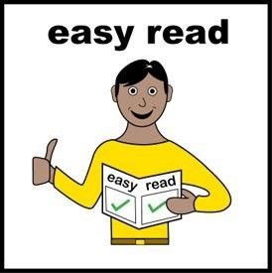

**Easy Read:**

**Freedom Festival 2025**

**A free outdoor festival of art, circus, and music**

**When is it?**

* Activities at Freedom Festival will take place between **Thursday 28th of August and Sunday 31st August**
* Most activities will take place on **Saturday 30th and** **Sunday 31st August 11am and 8pm.**
* You **don’t have to stay** the whole time.

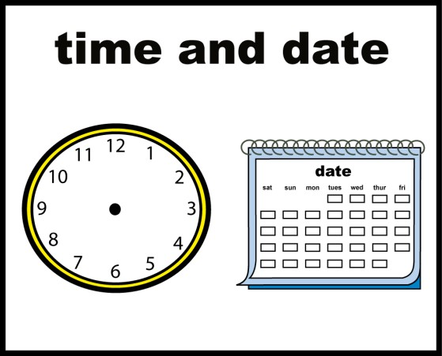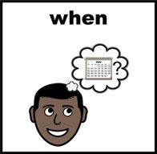

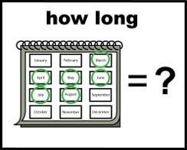

**Where is it?**

Freedom Festival will happen across **Hull city centre.** It will be organised into three zones. Here is a map of the festival site

**How to get there:**

* **Paragon Interchange bus and train station** is about a fifteen-minute walk to the festival.
* There are **blue badge parking bays** on streets around the festival and in several car parks that are close by
* There is more travel information on our **website access page** including a list of car parks

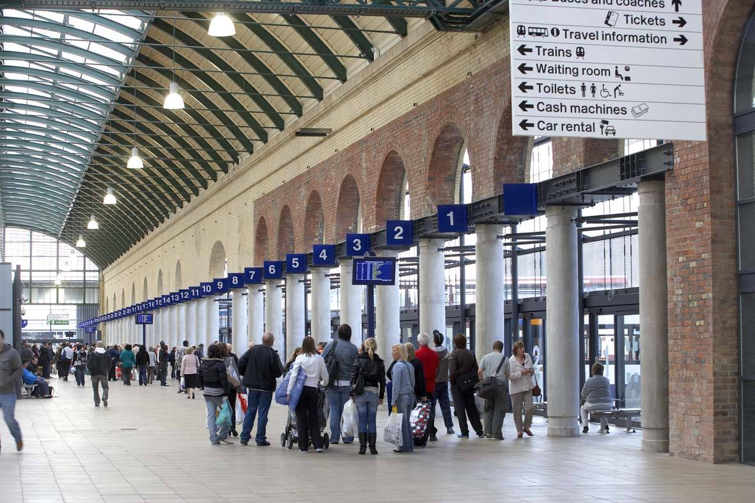

**What to expect?**

* It may be **busy** with lots of people.
* You can **come and go** as you like.
* It will be **fun** for the whole family!
* If you ever need any help, you can **ask a volunteer.** They’ll be wearing their HEY Volunteering blue uniform.

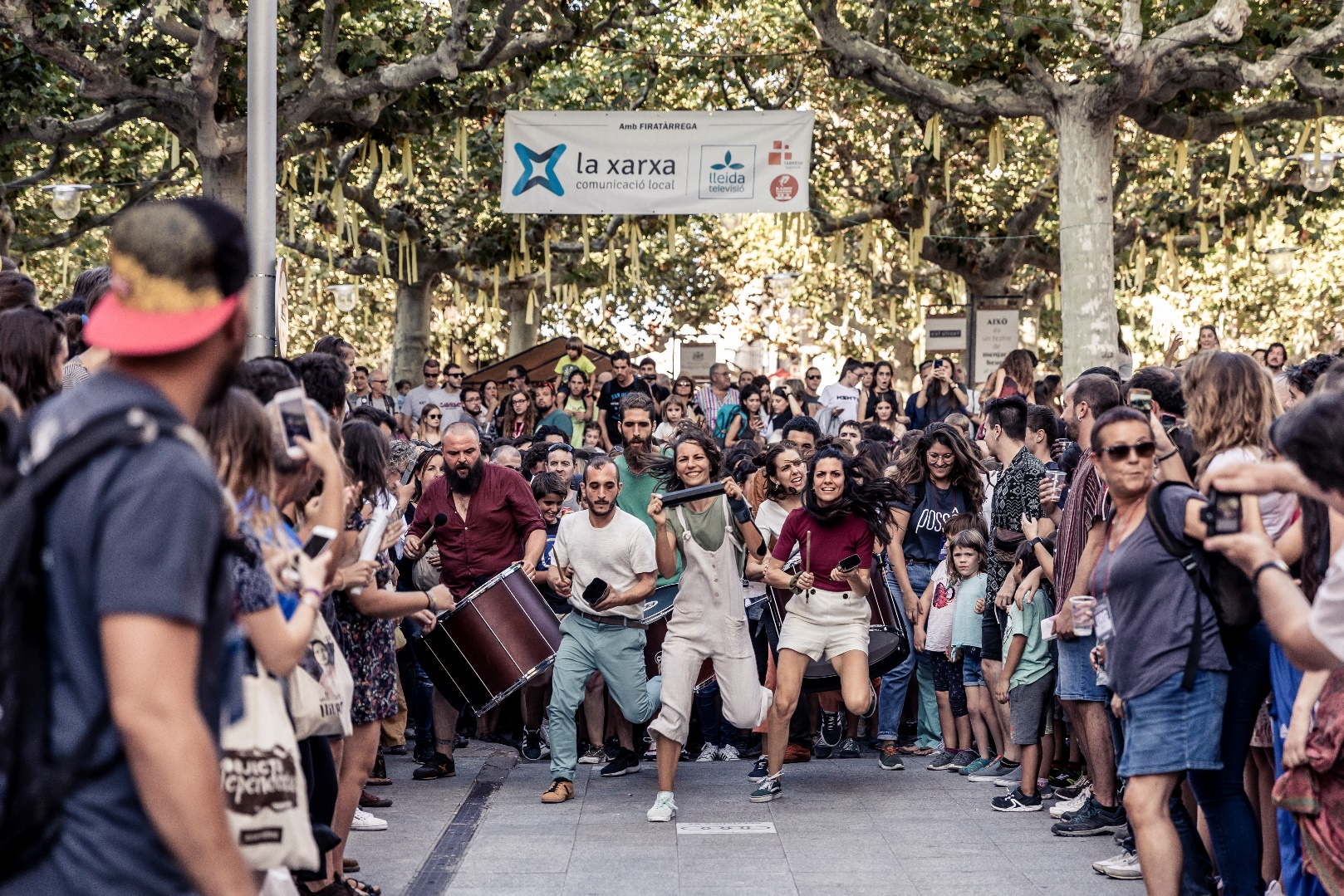**What will you see?**

In Zone 1 you will see many shows including Posse, a fun drumming parade.

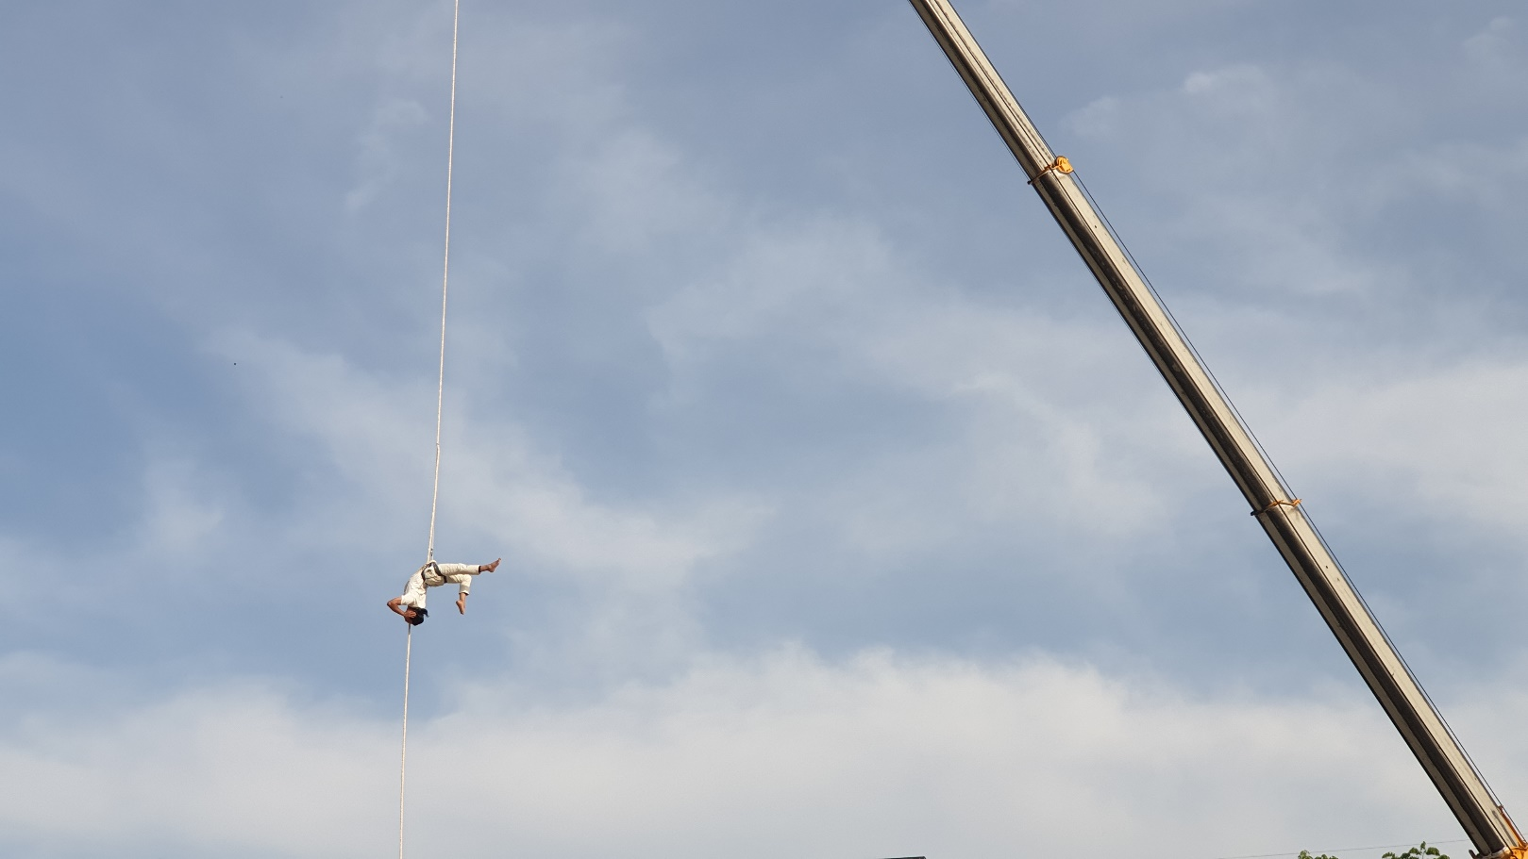**What will you see?**

In **zone 2** you will see many shows including Breath- an amazing acrobat.

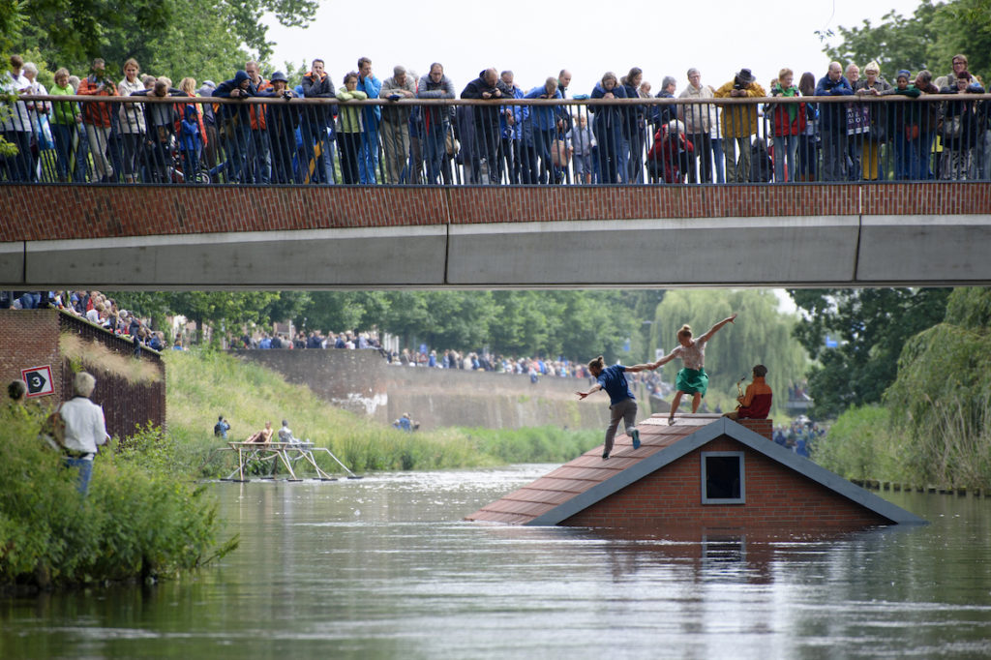**What will you see?**

In **Zone 3** you will see many shows including this show in the water- Sliding Slope.

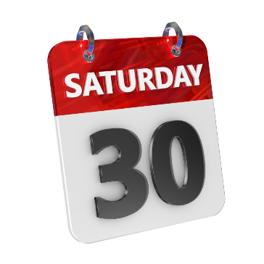

**What should I go and watch?**

|  |  |  |
| --- | --- | --- |
| **Show Name** | **Place** | **Time** |
| Parade | Queen Victoria Square | 11.00am |
| Pirate Taxi | Zebedee’s Yard | 2.15pm |
| Castaway | Zebedee’s Yard | 4.30pm |
| Breath | Trinity Square | 7.30pm |
| Suma | Queen Victoria Square | 9.00pm |

You can go and see whatever you would like but we’ve picked some shows and times out for **Saturday** **30th August**.

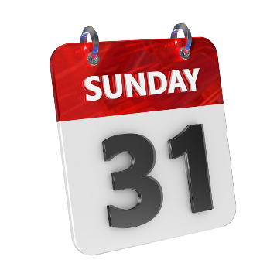 **What should I go and watch?**

|  |  |  |
| --- | --- | --- |
| **Show Name** | **Place** | **Time** |
| Pentagon | Beverley Gate | Any time- opens 11.00am |
| Anchored in Air | Zebedee’s Yard | 12.00pm |
| Electric Feel | Princes Dock St | 1.00pm |
| Posse | Whitefriargate | 14.00pm |
| Sliding Slope | Marina | 3.30pm |

You can go and see whatever you would like but we’ve picked some shows and times out for **Sunday 31st August.**

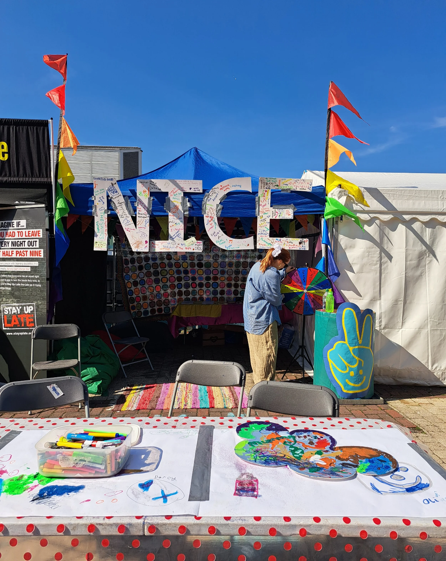**Nice Twice Club** and **Gig Buddies** can help with access support during the festival. They will be on Princes Dock Street. We also have access volunteers around the site with Dan from Elephant in the Room inclusion.

Ask a volunteer to show you where to go for this.

**Accessible shows**

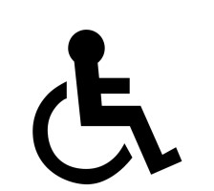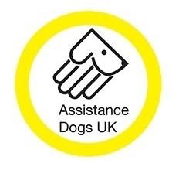

* Many shows will have BSL
* Many shows will have Audio Description
* All sites are wheelchair accessible
* We welcome assistance dogs

**You can find dates and times for BSL and Audio Described shows on our website and in our programme.**

**Photography and filming**



We have photographers and film makers at events to capture footage to share online and for use in future.

If you don’t want to be featured, **please wear a ‘No Photography’ sticker, available from our Info Point.**

**For more information:**

**Check out our website:** <https://www.freedomfestival.co.uk/festival-accessibility/>

**Email:** [**access@freedomfestival.co.uk**](mailto:access@freedomfestival.co.uk)

**Phone:** 01482 818379

**Staff and volunteers will be at the festival and always happy to chat!**

**We look forward to seeing you there!**

